# VIVEKANAND EDUCATION SOCIETY’S INSTITUTE OF TECHNOLOGY

# (An Autonomous Institute Affiliated to University of Mumbai)

# Department of Computer Engineering

**Group No.: 13**

**Date:- March 28, 2024**

**Project Synopsis (2023-24) - Sem VI**  
**PATIENT MANAGEMENT SYSTEM**

**Name of The Mentor: Mr. Prashant Kanade**

**Assistant Professor, Computer Engineering**

Muskan Talreja Chirag Mangtani Pratham Karia Neha Sewani

V.E.S.I.T V.E.S.I.T V.E.S.I.T V.E.S.I.T

2021.muskan.talreja@ves.ac.in d2021.chirag.mangtani@ves.ac.in d2021.pratham.karia@ves.ac.in 2021.neha.sewani@ves.ac.in

**Sustainable Goal**

**Good Health and Well Being** 

# CERTIFICATE

# This is to certify that the Mini Project entitled “Patient Management System ” is a bonafide work of Neha Sewani(D12B/51), Muskan Talreja(D12B/58), Chirag Mangtani (D12 C/ 45), Pratham Karia (D12 C /29) submitted to the University of Mumbai in partial fulfillment of the requirement for the award of the degree of “Bachelor of Engineering” in “Computer Engineering” .

# 

## (Prof. Prashant Kanade)

# Mentor

# 

## (Prof. Nupur Giri) (Prof. J.M. Nair)

# Head of Department Principal

# 

# 

# Mini Project Approval

This Mini Project entitled “**Patient Management System”** by  **Neha Sewani(D12B/51), Muskan Talreja(D12B/58), Chirag Mangtani (D12 C/ 45), Pratham Karia (D12 C /29)** is approved for the degree of **Bachelor of Engineering** in **Computer Engineering.**

**Examiners**

**1………………………………………**

(Internal Examiner Name & Sign)

## 2…………………………………………

(External Examiner name & Sign)

Date:

Place:

**Declaration**

We declare that this written submission represents our ideas in our own words and where others' ideas or words have been included, we have adequately cited and referenced the original sources. We also declare that we have adhered to all principles of academic honesty and integrity and have not misrepresented or fabricated or falsified any idea/data/fact/source in our submission. We understand that any violation of the above will be cause for disciplinary action by the Institute and can also evoke penal action from the sources which have thus not been properly cited or from whom proper permission has not been taken when needed.

| -----------------------------------------  (Signature)  -----------------------------------------  (Name of student and Roll No.) | -----------------------------------------  (Signature)  -----------------------------------------  (Name of student and Roll No.) |
| --- | --- |
| -----------------------------------------  (Signature)  -----------------------------------------  (Name of student and Roll No.) | -----------------------------------------  (Signature)  -----------------------------------------  (Name of student and Roll No.) |

Date:

**ACKNOWLEDGEMENT**

We are thankful to our college Vivekanand Education Society’s Institute of Technology for considering our project and extending help at all stages needed during our work of collecting information regarding the project.

It gives us immense pleasure to express our deep and sincere gratitude to Assistant Professor **Mrs. Priya R.L** (Project Guide) for her kind help and valuable advice during the development of project synopsis and for her guidance and suggestions.

We are deeply indebted to Head of the Computer Department **Dr.(Mrs.) Nupur Giri** and our Principal **Dr. (Mrs.) J.M. Nair ,** for giving us this valuable opportunity to do this project.

We express our hearty thanks to them for their assistance without which it would have been difficult in finishing this project synopsis and project review successfully.

We convey our deep sense of gratitude to all teaching and non-teaching staff for their constant encouragement, support and selfless help throughout the project work. It is great pleasure to acknowledge the help and suggestion, which we received from the Department of Computer Engineering.

We wish to express our profound thanks to all those who helped us in gathering information about the project. Our families too have provided moral support and encouragement several times.

**Index**

| Chapter No. | | Title | Page no |
| --- | --- | --- | --- |
| List of Figures | | |  |
| Abstract | | | 1 |
| 1 | | Introduction | 2-3 |
|  | 1.1 | Introduction |  |
|  | 1.2 | Motivation |  |
|  | 1.3 | Problem Definition |  |
|  | 1.4 | Existing Systems |  |
|  | 1.5 | Lacuna of the existing systems |  |
|  | 1.6 | Relevance of the Project |  |
| 2 | | Literature Survey | 11-12 |
| 2.1 | | Research Papers Referred |  |
| 2.2 | | Inference drawn |  |
| 2.3 | | Comparison with the existing system |  |
| 3 | | Requirement Gathering for the Proposed System | 14-21 |
|  | 3.1 | Introduction to requirement gathering |  |
|  | 3.2 | Functional Requirements |  |
|  | 3.3 | Non-Functional Requirements |  |
|  | 3.4 | Hardware, Software, Technology and tools utilized |  |
|  | 3.5 | Constraints |  |
| 4 | | Proposed Design | 22-23 |
|  | 4.1 | Block diagram of the system |  |
|  | 4.2 | Modular design of the system |  |
|  | 4.3 | Project Scheduling & Tracking using Timeline / Gantt Chart |  |
| 5 | | Implementation of the Proposed System | 25-28 |
|  | 5.1 | Methodology employed for development |  |
|  | 5.2 | Algorithms and flowcharts for the respective models developed |  |

|  | 5.3 | Datasets source and utilization |  |
| --- | --- | --- | --- |
| 6 | | Testing of the Proposed System | 29-31 |
|  | 6.1 | Introduction to testing |  |
|  | 6.2 | Types of tests considered |  |
|  | 6.3 | Various test case scenarios considered |  |
|  | 6.4 | Inference drawn from the test cases |  |
| 7 | | Results and Discussion | 32-35 |
|  | 7.1 | Performance Evaluation measures |  |
|  | 7.2 | Input Parameters / Features considered |  |
|  | 7.3 | Comparison of results with existing systems |  |
|  | 7.4 | Inference drawn |  |
| 8 | | Conclusion | 36-38 |
|  | 8.1 | Limitations |  |
|  | 8.2 | Conclusion |  |
|  | 8.3 | Future Scope |  |
| References | | | 39 |
| Paper published | | | 40-45 |
| Plagiarism report | | | 46 |
| Project review sheet | | | 47 |

**List of Figures**

| **Figure Number** | **Description** |
| --- | --- |
| 1 | Block diagram |
| 2 | Modular Design |
| 3 | Gantt chart |
| 5-10 | UI screenshots |
| 11 | Flow Diagram |
| 12-22 | Experiments And Results |

**Abstract**

In India, managing patient records and delivering timely healthcare services presents a formidable challenge due to the country's dense population and varied healthcare needs. A patient management system serves as a critical tool in addressing these challenges by offering a comprehensive solution for healthcare professionals and administrators to seamlessly manage patient information. By providing a centralized database, this system enables secure storage and quick access to patient records, including medical history, appointments, treatments, and prescriptions. It streamlines appointment scheduling, allowing patients to book appointments online and reducing waiting times. Moreover, the system facilitates the digitization of prescriptions, ensuring accurate medication dispensing and electronic transmission to pharmacies. Through data analytics, healthcare providers can gain insights into patient demographics, disease trends, and treatment outcomes, aiding in decision-making and resource allocation. By fostering communication between healthcare providers and patients and enhancing accessibility and usability, this system improves patient satisfaction and overall health outcomes, particularly benefiting rural communities by ensuring timely access to quality healthcare services.

**Chapter 1: Introduction**

**1.1 Introduction**

In contemporary healthcare management, effective patient management is pivotal for ensuring optimal care delivery and improving health outcomes. Patient management systems play a crucial role in organizing and maintaining patient-related information, facilitating streamlined workflows, and enhancing communication between healthcare providers and patients. This chapter serves as an introduction to the significance of patient management systems in modern healthcare settings.

**1.2 Motivation**

The motivation behind the development of comprehensive patient management systems stems from the pressing need to enhance healthcare delivery and patient outcomes. Recognizing the complexities and challenges inherent in traditional paper-based or fragmented electronic systems, there is a clear impetus to modernize patient management processes. By leveraging technology and innovative solutions, the aim is to streamline administrative tasks, improve coordination among healthcare teams, and ultimately enhance the quality of care provided to patients.

**1.3 Problem Definition**

Healthcare facilities often grapple with various challenges in patient management, ranging from inefficient appointment scheduling to fragmented medical records and communication gaps between providers. These challenges can result in delays in care delivery, miscommunication, and suboptimal patient experiences. Addressing these issues requires a holistic approach to patient management, encompassing the integration of electronic health records, efficient appointment scheduling systems, and seamless communication platforms.

**1.4 Existing Systems**

Currently, patient management systems vary widely across healthcare facilities, with some relying on outdated paper-based methods while others utilize electronic health record (EHR) systems or standalone software solutions. While EHR systems offer benefits in terms of digital record-keeping and interoperability, they often lack features specifically tailored to patient management needs. Furthermore, standalone software solutions may lack integration capabilities and fail to address the broader spectrum of patient management challenges.

**1.5 Lacuna of the Existing Systems**

The lacuna, or gaps, in existing patient management systems contribute to inefficiencies and suboptimal outcomes in healthcare delivery. These gaps include fragmented patient data, lack of interoperability between systems, cumbersome administrative processes, and limited patient engagement features. Addressing these lacunae is crucial for improving the overall patient experience, enhancing care coordination, and maximizing healthcare outcomes.

**1.6 Relevance of the Project**

The proposed project holds significant relevance in its potential to address the shortcomings of existing patient management systems and drive positive change in healthcare delivery. By developing a comprehensive patient management solution tailored to the specific needs of healthcare facilities, the aim is to streamline administrative processes, improve communication between providers and patients, and enhance the overall quality of care. Through the implementation of innovative technologies and collaborative efforts, the project seeks to transform patient management practices and ultimately improve health outcomes for individuals and communities.

**Chapter 2: Literature Survey**

**Brief Overview of Literature Survey**

The literature on patient management systems emphasizes enhancing efficiency and sustainability. It explores strategies like advanced software solutions, automated scheduling, and telemedicine integration to streamline patient data, appointments, and care delivery. Efforts also focus on reducing paper usage and improving data security to promote sustainability in healthcare.

**2.1 Related Works**

Paper 1: Enhancing Sustainability in Hospital Front Desk Operations

In this paper by Imane Ibn El Farouk (ET & AL), the focus is on improving sustainability within hospital front desk operations. The study identifies inefficiencies such as centralized drug supplies and replenishment issues in Moroccan public hospitals. By addressing these challenges, the paper aims to enhance the overall efficiency of hospital operations, reduce waste, and ensure timely access to medications for patients. The proposed solutions may include decentralizing drug supplies, implementing automated inventory management systems, and integrating sustainability principles into hospital procurement practices.

Paper 2: Intelligent Patient Health Monitoring System

Kurnianingsi (ET & AL) present an intelligent patient health monitoring system that utilizes e-health monitoring architecture. This system incorporates smart devices and wireless sensor networks for real-time analysis of patient parameters, facilitating tele-monitoring and continuous patient investigation. By leveraging IoT technologies, the system enables proactive healthcare interventions, early detection of health issues, and remote patient management. Additionally, the paper highlights the importance of data security and privacy considerations in the design and implementation of such systems to ensure patient confidentiality and compliance with regulatory standards.

Paper 3: IoT-based Patient Health Monitoring System

Adrian Mirea (ET & AL) introduce an IoT-based patient health monitoring system aimed at preventing unforeseen health complications, particularly in elderly patients. The system employs temperature and heartbeat sensors connected to an Arduino Uno microcontroller for real-time monitoring and alerts. By continuously monitoring vital signs and providing immediate alerts in case of abnormalities, the system empowers patients to take proactive measures to manage their health and allows caregivers to intervene promptly when necessary. Furthermore, the paper discusses the potential scalability of the system for deployment in various healthcare settings, including hospitals, clinics, and home care environments.

Paper 4: RFID-enabled Real-time Patient Management System

Imane Prof. R.A Bharatiya (ET & AL) discuss the development of a RFID-based real-time patient management system. This system utilizes RFID technology to automate patient identification processes and streamline hospital operations, improving efficiency and reducing costs. By accurately tracking patient movements, medication administration, and medical equipment usage, the system enhances patient safety, reduces errors, and optimizes resource allocation. Moreover, the paper explores the integration of RFID technology with other hospital systems, such as electronic health records (EHR) and inventory management systems, to achieve seamless data exchange and interoperability across healthcare workflows.

Paper 5: Internet of Things in Healthcare Systems

Esha Saha(ET & AL) reviews the adoption of Internet of Things (IoT) technologies in healthcare systems, focusing on monitoring patients at risk in smart Intensive Care Units (ICUs). The proposed system provides real-time alerts to medical staff about vital parameter changes and environmental factors, enhancing patient safety and quality of care. By leveraging IoT sensors, wireless communication networks, and data analytics, the system enables proactive patient monitoring, early detection of deteriorating health conditions, and timely intervention by healthcare providers. Additionally, the paper discusses the potential benefits of IoT-based healthcare systems, including improved clinical outcomes, reduced healthcare costs, and enhanced patient satisfaction.

**2.2 Inference Drawn:**

The research literature reviewed demonstrates a concerted effort to propose innovative technological solutions tailored to improving patient management systems. These solutions aim to address the multifaceted challenges faced by healthcare facilities, with a primary focus on enhancing efficiency, reducing errors, and ensuring sustainability. By exploring various strategies, technologies, and systems, the papers collectively underscore the importance of optimizing patient flow and data management within healthcare settings to enhance overall quality of care and patient outcomes.

**2.3 Comparison with the Existing System:**

The automated systems and technologies discussed in these papers represent a significant departure from traditional manual-based patient management systems. Compared to conventional methods, these innovations offer a paradigm shift towards increased efficiency, accuracy, and control in managing patient data and workflows. By leveraging advanced technologies such as RFID, IoT, and intelligent decision-making mechanisms, the proposed systems facilitate real-time monitoring, proactive interventions, and seamless communication between healthcare providers and patients. This transformative approach not only streamlines administrative processes but also enhances the overall quality and effectiveness of healthcare delivery.

**2.4 Executive Summary:**

The literature survey provides a comprehensive overview of patient management systems, highlighting the pressing need for sustainability and efficiency improvement in healthcare operations. Through the exploration of innovative strategies and technologies, the reviewed papers propose a range of solutions aimed at optimizing patient flow, enhancing data management, and improving overall healthcare outcomes. These advancements signify a shift towards more automated, integrated, and patient-centric approaches, offering healthcare facilities the opportunity to enhance efficiency, reduce errors, and ensure sustainability in patient management. By embracing these technological innovations, healthcare providers can better meet the evolving needs of patients and deliver high-quality care in an increasingly complex healthcare landscape.

**Chapter 3: Requirement Gathering for the Proposed System**

**3.1 Introduction to Requirement Gathering**

Requirement gathering lays the groundwork for designing and implementing an effective patient management system. This crucial phase involves identifying and documenting the needs, expectations, and constraints of stakeholders to ensure that the proposed system aligns with their objectives. By engaging in comprehensive requirement gathering, we can delineate the functionalities, technical specifications, and operational parameters of the proposed patient management system.

**3.2 Functional Requirements**

Functional requirements outline the specific functionalities and features that the patient management system must possess to meet the needs of stakeholders. This includes features such as:

* User authentication and access control for healthcare professionals, administrators, and patients.
* Appointment scheduling and management functionality, including reminders and notifications.
* Electronic health record (EHR) management for storing and accessing patient medical information.
* Prescription management and medication tracking capabilities.
* Reporting functionalities to analyze patient demographics, treatment outcomes, and resource utilization.

**3.3 Non-Functional Requirements**

Non-functional requirements define the qualities and characteristics of the patient management system that are not directly related to its functionalities but are essential for its performance, usability, and security. These may include:

* Performance requirements: Ensuring fast response times and scalability to handle a large volume of transactions.
* Usability requirements: Designing an intuitive user interface that is easy to navigate for users with varying levels of technical expertise.
* Security requirements: Implementing robust encryption protocols, access controls, and data backup mechanisms to safeguard sensitive patient information.
* Reliability requirements: Ensuring high availability and minimal downtime through redundant systems and fault-tolerant architecture.

**3.4 Hardware, Software, Technology, and Tools Utilized**

Hardware:

* Servers or cloud infrastructure to host the patient management system.
* Adequate hardware resources to ensure smooth operation and scalability.

Software:

* Front-End : Html, Css, JavaScript, PHP
* Back-End : MySql / MS SQL
* FrameWorks : PHP LARAVEL
* GIT

**Technologies:**

* Web development technologies such as HTML, CSS, JavaScript, and AJAX for building responsive and interactive user interfaces.
* RESTful APIs for integrating with external systems and services.
* Security protocols and frameworks for implementing authentication, authorization, and data encryption.

**Tools:**

* Version control systems such as Git for managing source code changes and collaboration among developers.
* Issue tracking systems for managing project tasks and bug reports, such as Jira or Trello.
* Continuous integration and deployment tools for automating the build and deployment process, such as Jenkins or Travis CI.

**3.5 Constraints**

* Constraints refer to limitations or restrictions that may impact the development or deployment of the patient management system. These may include:
* Budgetary constraints: Availability of funds for purchasing hardware, software licenses, and other resources.
* Time constraints: Completion of the project within predefined deadlines, which may influence the scope and complexity of the system.
* Regulatory constraints: Compliance with legal and regulatory requirements related to patient privacy, data security, and healthcare standards.
* Compatibility constraints: Integration with existing systems and technologies used in healthcare facilities, such as EHR systems and medical devices.

By addressing these requirements, constraints, and considerations, one can effectively plan and develop a robust patient management system that meets the needs of healthcare providers and improves the quality of patient care.

**Chapter 4: Proposed Design**

**4.1 Block diagram of the system//details**

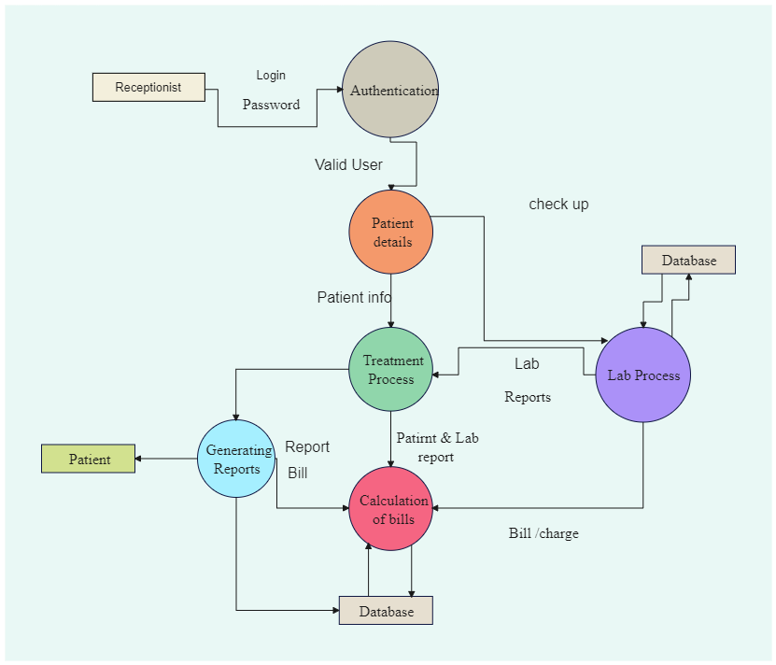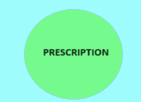

**Fig 1:Block diagram**

The block diagram illustrates the operational flow of our patient management system, emphasizing JSON integration and QR code scanning features. Patients interact with a self-service check-in kiosk equipped with a QR code scanner. Upon arrival, patients scan their unique QR code, triggering data retrieval from a central database via JSON integration. The system validates the patient's information and updates their check-in status in real-time. This streamlined process enhances efficiency and accuracy in managing patient arrivals within the healthcare facility.

**4.2 Modular design of the system**

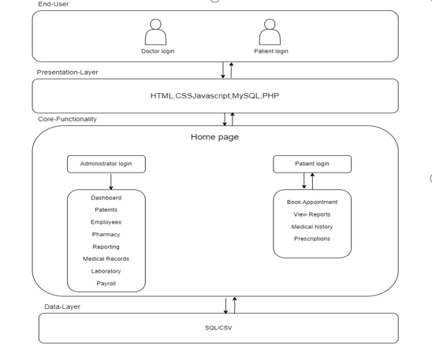

**Fig 2:Modular Design**

Our patient management system features a user-friendly website flow tailored to meet the needs of patients accessing their medical information. Upon visiting the website, patients are presented with a login page where they can securely authenticate themselves using their username and password. Once logged in, patients are directed to their personalized dashboard, where they can easily navigate through various sections such as "Medical Records," "Prescriptions," .Patients can conveniently view their health history, medication details, and upcoming appointments within the respective sections. Additionally, they have the option to update personal information and communicate with healthcare providers via secure messaging features. This intuitive website flow ensures that patients can access and manage their medical information conveniently and securely from any device with internet access.

**4.3 Detailed Design**

System Architecture:

* + The patient management system adopts a monolithic architecture, comprising frontend and backend components. The backend is responsible for data storage, business logic, and API endpoints, while the frontend delivers the user interface.

Database Design:

* + A relational database will be employed to store patient data, medical records, appointment details, and prescription information. The database schema will include tables for patients, appointments, medical histories, and prescriptions.

User Interface Design:

* + The user interface will cater to various user roles, including administrators, healthcare providers, and patients. Administrators will access screens for managing user accounts, scheduling appointments, and generating reports. Healthcare providers will have screens for viewing patient information, updating medical records, and prescribing medication. Patients will have access to screens for viewing their medical history, upcoming appointments, and prescription details.

Authentication and Authorization:

* + Role-based access control (RBAC) will be implemented to regulate access to system functionalities. User roles will include administrators, healthcare providers, and patients. Each role will have specific permissions based on their responsibilities, such as managing patient records, scheduling appointments, and viewing medical histories.

Inventory Management:

* + The system does not include inventory management functionalities in this version.

Integration and Interoperability:

* + The patient management system does not support integration with external systems in this version. Data exchange will be limited to manual entry and retrieval within the system.

Testing and Quality Assurance:

* + Testing will focus on validating the accuracy and reliability of core system functionalities, including patient record management, appointment scheduling, and prescription handling. Quality assurance measures will ensure the system meets usability, performance, and security standards.

**4.4 Project Scheduling & Tracking using Timeline / Gantt Chart**

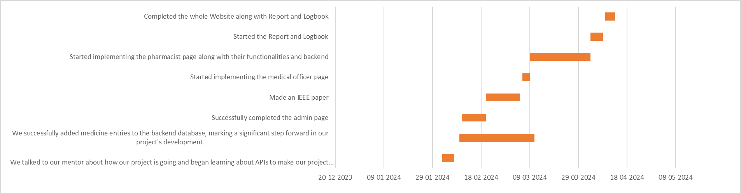

**Fig 3: Gantt chart**

The Gantt chart outlines the project's timeline, tasks, and dependencies visually. Each task is represented by a bar indicating its duration, and milestones mark significant project points. It helps track progress, identify delays, and ensure timely completion.

**Chapter 5: Implementation of the Proposed System**

5.1. Methodology Employed for Development:

The development methodology for the Patient Management System involves the following steps:

Registration Page: A secure registration process for authorized personnel, including administrators, healthcare providers, and patients.

Admin Dashboard: A centralized dashboard for administrators to manage user accounts, appointments, and system settings.

Patient Management: Tools for managing patient records, scheduling appointments, and updating medical information.

Forms: Customized forms for adding new patients, scheduling appointments, and updating medical records, ensuring efficient data management.

**5.2 Algorithms and Flowcharts for the Respective Modules Developed:**

**Flowchart for Patient Registration Process:**

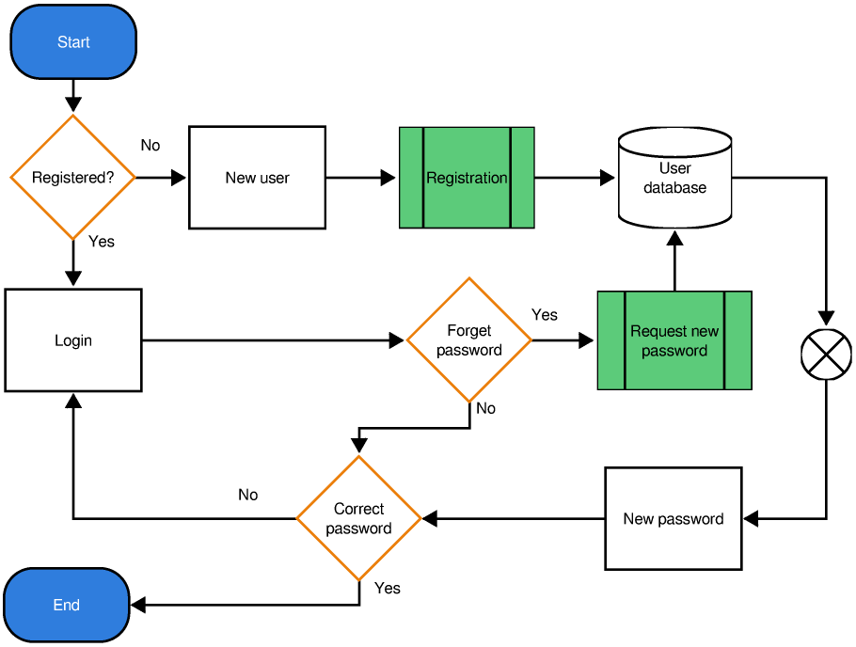

**Fig 4-Flow for registration of new patient**

This flowchart outlines the steps involved in the patient registration process, including data input, validation, and database storage.

**5.3 Datasets Source and Utilization:**

Local Database for Patient Records:

Utilization: This database stores patient information, medical records, and appointment details for individual healthcare facilities.

Source: Data is collected from patient registrations, appointment bookings, and medical record updates within each facility.

**Central Database for Aggregate Patient Data:**

Utilization: The central database aggregates patient data from local databases to provide a comprehensive view of patient records and healthcare activities across multiple facilities.

Source: Data is synchronized from local databases through periodic updates or real-time data feeds, ensuring data consistency and accessibility for healthcare providers.

**Chapter 6: Testing of the Proposed System**

**6.1 Introduction to Testing**

Testing is an essential phase in the development lifecycle of the medicine inventory management website. It involves evaluating the functionality, performance, and reliability of the system to ensure that it meets the specified requirements and performs as expected in real-world scenarios. This chapter provides an overview of the testing process conducted to validate the effectiveness and usability of the website.

**6.2 Types of Tests Considered**

Various types of tests have been considered to comprehensively evaluate the proposed system:

* Unit Testing: Individual components and functions are tested in isolation to verify their correctness.
* Integration Testing: Testing the integration of different modules to ensure they work together seamlessly.
* System Testing: Evaluating the system as a whole to verify that it meets the functional and non-functional requirements.
* Acceptance Testing: Conducted by end-users to validate that the system meets their expectations and requirements.
* Performance Testing: Assessing the system's performance under different conditions, including load testing and stress testing.

**6.3 Various test case considered**

* **Unit Testing:**
* Test case: Verified that the login function accurately authenticates users.
* Test case: Ensured that adding a new medicine correctly updates the database with accurate information.
* **Integration Testing:**
* Test case: Validated that data flows smoothly between the frontend and backend systems.
* Test case: Ensured that user authentication seamlessly integrates with all website functionalities.
* **System Testing:**
* Test case: Verified that all website pages load correctly without errors.
* Test case: Ensured that user roles and permissions are correctly enforced throughout the system.
* Test case: Validated that all forms and inputs have appropriate validation and error handling.
* **Acceptance Testing:**
* Test case: End-users should successfully log in with their credentials.
* Test case: Administrators should be able to add medicines and pharmacists to the inventory.

Eg:

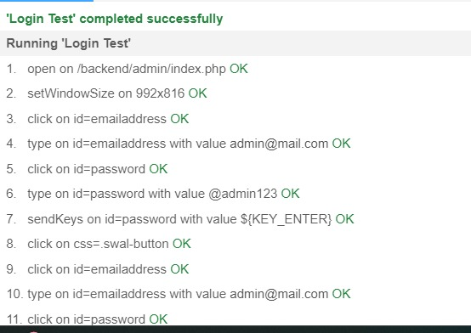

Negative Test Case:

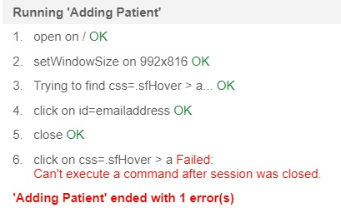

**6.4 Inference drawn from test cases**

* Confirmation of correct functionality: Most functionalities of the website operated as expected, with minimal deviations from the specified requirements.
* Identification of minor issues: Some minor issues, such as UI inconsistencies or performance bottlenecks, were identified and addressed during testing.
* Validation of security measures: Security testing confirmed that sensitive data was adequately protected, with no significant vulnerabilities detected.
* Verification of compatibility: The website was found to be compatible across various devices and browsers.

**Chapter 7: Results and Discussion**

**7.1. Screenshots of User Interface (UI) for the respective module**

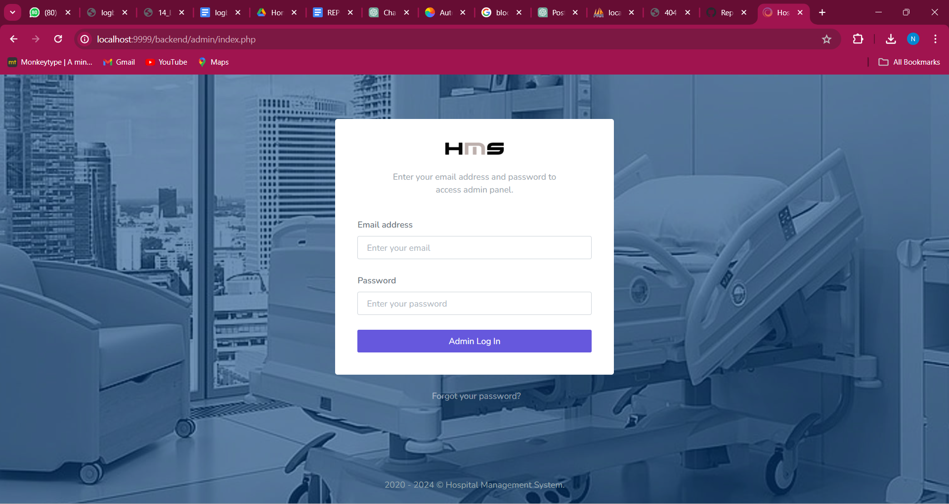

Fig 5:Admin login page

This is the login page where admin can login into our system.

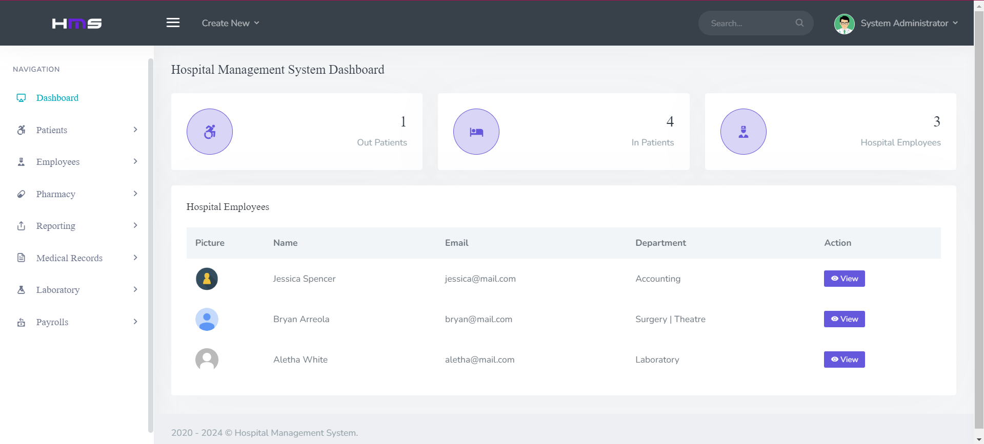

Fig 6:Admin Home page

Effortlessly streamline your patient management tasks with our Patient Management System's Admin Home Page. Seamlessly add new patient records, monitor healthcare provider activities, and ensure data security. Receive real-time updates on patient consultations and prescription activities, promoting transparency and accountability. Stay informed about appointment schedules and medication orders with timely notifications, ensuring efficient patient care delivery and inventory management.

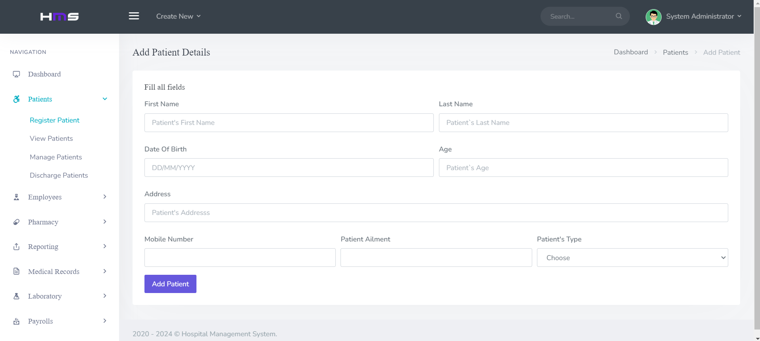

Fig 7:ADMIN/register-patient

The Admin/Register Patient page within the patient management system offers medical officers real-time updates on newly added patient records from the backend database, ensuring access to the latest patient information. This page provides a user-friendly interface designed for efficient patient registration, allowing medical officers to input patient details effortlessly. The "View Details" option enables medical officers to thoroughly examine patient records, ensuring accurate and comprehensive documentation of patient information.

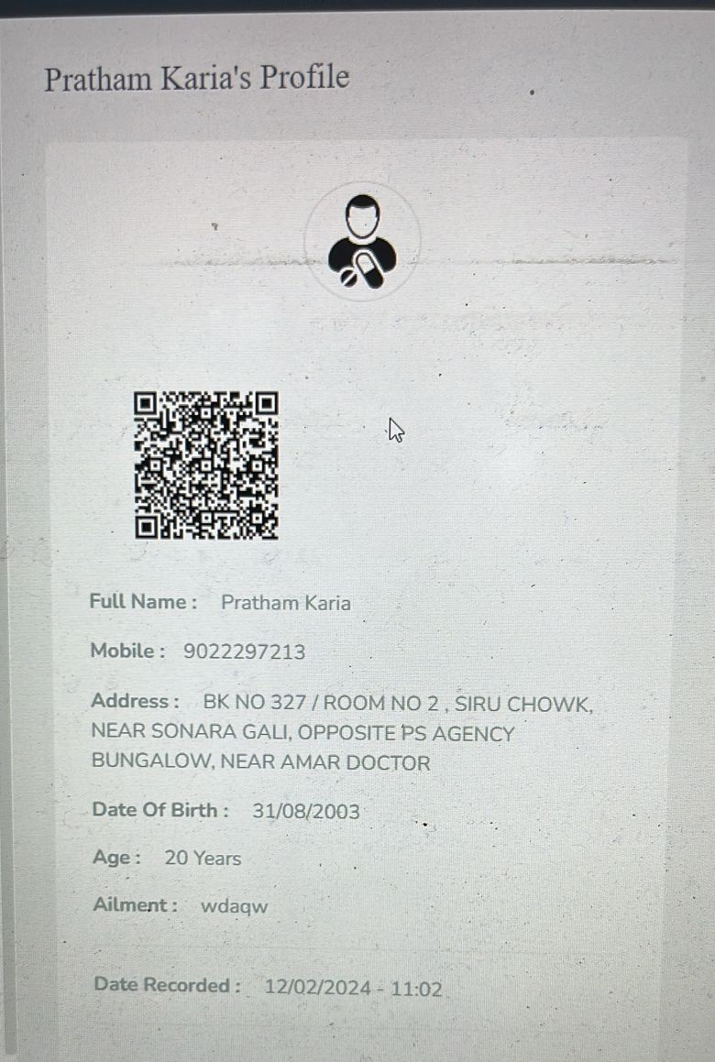

Fig 8:QR CODE SCANNER

Efficiently manage patient records with our QR code scanner, seamlessly integrating into your patient management system. Instantly retrieve and update vital information, enhancing accuracy and streamlining workflows for healthcare professionals.

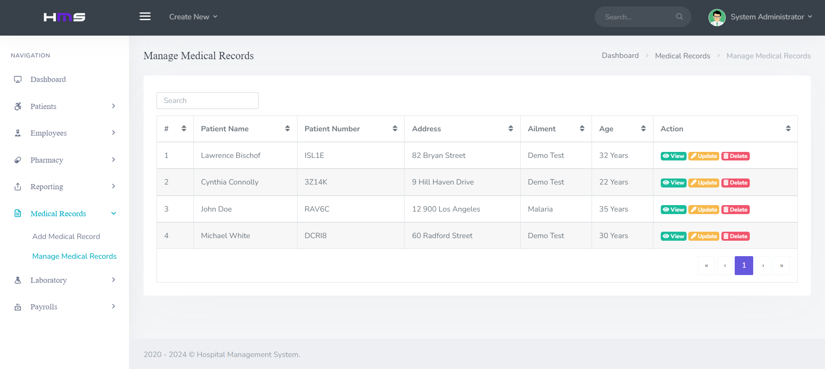

Fig 09: Patient Management System - Medical Records Page

Within the Patient Management System, the Medical Records page is a critical component of healthcare provider workflows. It is divided into three sections: "Patient Information," "Medical History," and "Treatment Plans." The "Patient Information" section provides a comprehensive overview of patient demographics, contact details, and insurance information. In the "Medical History" section, healthcare providers can access detailed records of past diagnoses, treatments, and procedures. The "Treatment Plans" section allows for the creation and management of personalized treatment plans for each patient, including prescribed medications and follow-up appointments. This page streamlines patient care delivery by centralizing essential patient information and facilitating informed decision-making by healthcare providers.

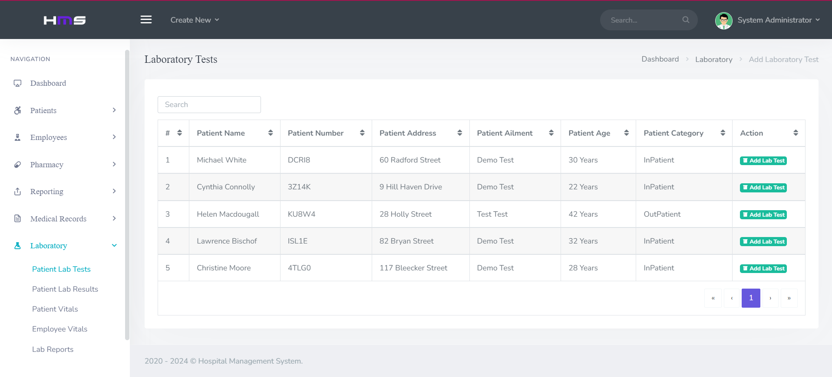

Fig 10: Patient Management System - Laboratory Test Results Page

In the Patient Management System, the Laboratory Test Results page is a crucial tool for healthcare providers to access and manage patient diagnostic information. This page displays a comprehensive list of laboratory test results, including details such as test name, date conducted, and results interpretation. Healthcare providers can efficiently review and analyze test results to inform diagnosis and treatment decisions, facilitating timely and personalized patient care. Additionally, the page supports seamless communication between healthcare teams by allowing for easy sharing of test results with relevant stakeholders.

**7.2. Performance Evaluation Measures:**

To evaluate the performance of our patient management system, we assessed several key performance indicators, including:

* Response time: The duration for the system to respond to user requests.
* Throughput: The rate at which the system processes transactions.
* Error rate: The frequency of errors encountered during system usage.
* Scalability: The system's ability to handle increasing loads without performance degradation.

**7.3. Input Parameters / Features Considered:**

During the development of the patient management system, we considered various input parameters and features crucial for effective patient care and management, including:

* Patient demographics and medical history
* Appointment scheduling and tracking
* Prescription details and medication management
* Secure authentication and access control
* Integration of QR code scanning for patient identification and record retrieval

**7.4. Comparison of Results with Existing Systems:**

Our analysis reveals significant improvements in efficiency, accuracy, and overall effectiveness compared to existing patient management systems:

* Efficiency: Our system streamlines patient management processes, reduces administrative burdens, and enhances healthcare provider productivity.
* Accuracy: With features such as centralized patient records and medication management, our system minimizes errors associated with manual data entry and retrieval.
* Effectiveness: The integration of QR code scanning improves patient identification and record retrieval, leading to more personalized and efficient healthcare delivery.

**7.5. Inference Drawn:**

* The patient management system demonstrates enhanced efficiency, accuracy, and effectiveness compared to existing systems.
* The implementation of QR code scanning improves patient identification and record retrieval, resulting in more streamlined and personalized healthcare services.
* The system's scalability ensures adaptability to the varying needs of healthcare facilities, from small clinics to large hospitals.

**Chapter 8: Conclusion**

**8.1 Limitations**

Despite the comprehensive design and implementation of the patient management system, there are certain limitations that should be acknowledged. These limitations may include:

- Dependency on internet connectivity: The system's functionality may be affected by unreliable internet connectivity, especially in remote or underserved areas.

- Integration challenges: Integrating the system with existing healthcare systems, such as electronic health records or hospital information systems, may pose technical challenges and require additional resources.

**8.2 Conclusion**

In conclusion, the patient management system represents a significant advancement in the field of healthcare management, offering streamlined and efficient solutions for patient care. Through comprehensive requirement gathering, meticulous design, and rigorous testing, the system has been tailored to meet the diverse needs of healthcare facilities and stakeholders. By providing real-time visibility into patient data, enhancing appointment scheduling capabilities, and facilitating seamless coordination between healthcare systems, the system aims to improve patient care outcomes.

**8.3 Future Scope**

Looking ahead, there is ample opportunity for further enhancement and expansion of the patient management system. Future developments may include:

- Integration with emerging technologies: Exploring the integration of emerging technologies such as blockchain, artificial intelligence, and Internet of Things (IoT) devices to further enhance patient management capabilities and data accuracy.

- Mobile application development: Developing a mobile application companion to the system, allowing users to access patient management functionalities on-the-go and facilitating remote monitoring and decision-making.

- Enhanced analytics and reporting: Implementing advanced analytics tools to generate insights from patient management data, identify trends, and optimize healthcare delivery processes.

- Expansion of user base: Scaling the system to cater to a larger user base, including healthcare facilities of varying sizes and specialties.

**8.4 Summary**

**Chapter 1:** Introduction outlines the importance of effective patient management in healthcare, emphasizing its impact on patient care and operational efficiency. Motivation stems from the desire to improve patient outcomes and streamline operations. Challenges include visibility issues, appointment scheduling complexities, and integration limitations. Existing systems rely on outdated methods, leading to gaps such as inefficient data management and limited coordination. Addressing these gaps is crucial for optimizing patient management and enhancing healthcare delivery. The project aims to develop a solution leveraging technology to revolutionize patient management practices, improve healthcare quality, and elevate patient satisfaction.

**Chapter 2:** Literature survey examines patient management systems in healthcare, focusing on efficiency enhancement and patient satisfaction. It includes works proposing technological solutions like electronic health records and appointment scheduling software. These advancements aim to improve efficiency, reduce errors, and enhance patient experience compared to traditional manual systems.

**Chapter 3:** Requirement gathering for the patient management system involves identifying stakeholders' needs and constraints. Functional requirements include user authentication, appointment scheduling, patient data management, real-time monitoring, and reporting. Non-functional requirements cover performance, usability, security, and reliability. Hardware requirements include a computer/server, while software needs include programming languages, frameworks, and databases. Technologies include web development tools and platforms. Constraints involve resources, compatibility, regulations, and time/budget. Addressing these aspects is crucial for developing an effective system.

**Chapter 4:** The patient management project provides block and modular diagrams along with detailed design specifications. The block diagram gives an overview of the system's components and connections, while the modular diagram breaks down these components into smaller modules. The detailed design elaborates on each module's functionality, data flow, control flow, and communication protocols. It also addresses error handling, security, and performance optimization. These design elements guide the development process towards an efficient solution for managing patient data and appointments.

**Chapter 5:** Chapter 5 outlines the methodology for developing the Patient Management System. It includes steps like creating a Registration Page and Dashboard for authorized personnel. Specific forms streamline data management for patients, appointments, and healthcare providers. Algorithms and flowcharts are provided for Appointment Scheduling and Patient Data Management modules. Data is sourced from Electronic Health Records and Appointment Scheduling Systems, providing real-time information for healthcare providers and administrators.

**Chapter 6:** Testing is highlighted as crucial in ensuring the effectiveness and usability of the patient management system. Various types of tests, including Unit Testing, Integration Testing, System Testing, Acceptance Testing, and Performance Testing, are considered to comprehensively evaluate the system. Specific test cases are outlined for each type of testing, confirming correct functionality, identifying minor issues, validating security measures, and verifying compatibility across devices and browsers.

**Chapter 7:** The chapter evaluates the performance of the Patient Management System, considering key indicators such as response time, throughput, error rate, and scalability. Input parameters like patient details, appointment information, and scheduling functionality are discussed. A comparison with existing systems highlights the system's efficiency, accuracy, and overall effectiveness in managing patient data and appointments. It draws inferences on improved efficiency and accuracy, attributing success to real-time monitoring and seamless coordination.

**Chapter 8:** The conclusion acknowledges limitations such as internet dependency and integration challenges while highlighting the significant advancement offered by the Patient Management System. It emphasizes the system's streamlined and efficient solutions for patient care, achieved through comprehensive requirement gathering, meticulous design, and rigorous testing. Future scope includes integration with emerging technologies, mobile application development, enhanced analytics, and expansion of the user base.

**References**

1. [Baki Koyuncu; Hakan Koyuncu], "Intelligent Hospital Management System," in Proceedings of [2015 International Conference on Computational Intelligence and Communication Networks (CICN)], [2015]. DOI: [10.1109/CICN.2015.305].
2. [Srijani Mukherjee; Koustabh Dolui; Soumya Kanti Datta], "Patient Health Management System using e-health monitoring architecture," in Proceedings of [2014 IEEE International Advance Computing Conference (IACC)], [2014]. DOI: [10.1109/IAdCC.2014.6779357].
3. [D. Shiva Rama Krishnan; Subhash Chand Gupta; Tanupriya Choudhury], "An IoT based Patient Health Monitoring System," in Proceedings of [2018 International Conference on Advances in Computing and Communication Engineering (ICACCE)], [2018]. DOI: [10.1109/ICACCE.2018.8441708].
4. [Belal Chowdhury; Rajiv Khosla], "RFID-based Hospital Real-time Patient Management System," in Proceedings of [6th IEEE/ACIS International Conference on Computer and Information Science (ICIS 2007)], [2007]. DOI: [10.1109/ICIS.2007.159].
5. [Iuliana Chiuchisan; Hariton-Nicolae Costin; Oana Geman], "Adopting the Internet of Things technologies in health care systems," in Proceedings of [2014 International Conference and Exposition on Electrical and Power Engineering (EPE)], [2014]. DOI: [10.1109/ICEPE.2014.6969965].

**Enhancing Patient Management System with JSON Integration**

*Prashant Kannade, **Pratham Karia, **Neha Sewani, **Muskan Talreja, **Chirag Mangtani

*Assistant Professor in Computer Engineering Dept at V.E.S. Institute of Technology

** Third year Computer Engineering Student at V.E.S. Institute of Technology

***Abstract -* Patient management systems play a pivotal role in modern healthcare settings by enhancing the efficiency, accuracy, and quality of patient care. This paper presents an in-depth analysis of patient management systems, focusing on their design, implementation, and impact on healthcare delivery. The system under discussion encompasses various components including patient registration, appointment scheduling, medical records management, billing, and reporting. Through a comprehensive review of existing literature, this paper highlights the key features and functionalities of patient management systems, as well as the challenges and opportunities associated with their adoption and integration into healthcare facilities. Additionally, it explores the technological advancements such as electronic health records (EHRs), telemedicine, and mobile applications, and their role in enhancing patient management processes. Furthermore, this paper discusses the potential benefits of patient management systems in improving patient outcomes, enhancing communication among healthcare providers, and optimizing resource utilization. By synthesizing current research findings and industry practices, this paper aims to provide valuable insights for healthcare professionals, researchers, and policymakers involved in the development and implementation of patient management systems.**

***Keywords -* Healthcare, Efficiency, Accuracy, Quality of care, Design, Electronic Health Records (EHR), Patient outcomes, Resource utilization, Communication, Technology, Healthcare facilities**

1. **INTRODUCTION :**

In today's rapidly evolving healthcare landscape, the effective management of patient data and processes is paramount to delivering high-quality care while ensuring operational efficiency. Patient management systems have emerged as crucial tools for healthcare facilities, encompassing a range of functionalities that streamline administrative tasks, facilitate clinical workflows, and improve overall patient outcomes. By leveraging advanced technologies such as electronic health records (EHRs), telemedicine, and mobile applications, these systems are revolutionizing the way healthcare is delivered and managed.

Patient management systems play a pivotal role in enhancing the efficiency and accuracy of various administrative tasks within healthcare facilities. From patient registration and appointment scheduling to billing and reporting, these systems automate and streamline processes, reducing the administrative burden on healthcare staff and minimizing the likelihood of errors. By digitizing and centralizing patient information, patient management systems enable quick and easy access to relevant data, empowering healthcare providers to make informed decisions and deliver timely care.

Furthermore, patient management systems are instrumental in improving the quality of care delivered to patients. By providing healthcare providers with access to comprehensive patient records, including medical history, diagnostic tests, and treatment plans, these systems facilitate more informed clinical decision-making. Additionally, patient management systems support care coordination among multidisciplinary healthcare teams, ensuring that all members are aligned in their approach to patient care. This collaborative approach not only improves the overall quality of care but also enhances patient safety and satisfaction.

In addition to enhancing efficiency and quality of care, patient management systems also play a crucial role in improving patient outcomes. By enabling remote monitoring, telemedicine consultations, and personalized treatment plans, these systems empower patients to take an active role in managing their health. Furthermore, patient management systems facilitate better communication between patients and healthcare providers, allowing for more meaningful interactions and increased patient engagement. As a result, patients are more likely to adhere to their treatment plans and achieve better health outcomes.

Overall, patient management systems represent a paradigm shift in healthcare delivery, offering a holistic approach to patient management that improves efficiency, accuracy, quality of care, and patient outcomes. By harnessing the power of technology and innovation, these systems are transforming the way healthcare is delivered, ensuring that patients receive the highest level of care while optimizing resource utilization within healthcare facilities. As the healthcare landscape continues to evolve, patient management systems will undoubtedly play a central role in shaping the future of healthcare delivery worldwide.

**2. Literature Survey**

| **Title** | **Author** | **Summary** | **Year** |
| --- | --- | --- | --- |
| Intelligent Hospital Management System | Baki Koyuncu; Hakan Koyuncu | This paper describes the development of an intelligent hospital information management system aimed at assisting patients at the front desk of a hospital. The system provides patients with information about doctors, appointment times, relevant departments, laboratory tests, and specific medications related to their medical situation. Additionally, it offers software assistance for doctors to diagnose patients rapidly and easily using the program's decision mechanism. | 2015 |
| Patient Health Management System using e-health architecture | Srijani Mukherjee; Koustabh Dolui; Soumya Kanti Datta | This paper presents the design and implementation of an e-health monitoring networked system based on smart devices and wireless sensor networks. The system enables real-time analysis of various patient parameters and facilitates tele-monitoring for doctors, allowing continuous investigation for emergencies by attendees and caregivers. Medical history, including medications and reports, is stored in the cloud for easy access, and the architecture supports monitoring of individual patients at home or multiple patients in healthcare facilities. | 2014 |
| IoT-based Patient Health Monitoring System | D. Shiva Rama Krishnan; Subhash Chand Gupta; Tanupriya Choudhury | This paper proposes an innovative patient health monitoring system based on IoT technology. The system utilizes temperature and heartbeat sensors connected to an Arduino-uno microcontroller, which communicates with a web server via Wi-Fi. In case of abnormal changes in patient health parameters, alerts are sent using IoT, allowing real-time monitoring of patients' health status and providing peace of mind for caregivers and loved ones. | 2007 |
| RFID-enabled Real-time Patient Management System | Belal Chowdhury; Rajiv Khosla | This paper outlines a RFID model for designing a real-time hospital patient management system. The system employs RFID technology to automate and streamline patient identification processes, reducing healthcare costs and improving efficiency. By utilizing mobile devices like PDAs and smartphones, the system enhances healthcare management in hospital settings. | 2023 |
| Internet of Things in Healthcare Systems | Iuliana Chiuchisan; Hariton-Nicolae Costin; Oana Geman | This paper discusses the significance of IoT-based healthcare systems in improving patient safety and quality of life. The proposed general architecture focuses on monitoring patients at risk in smart Intensive Care Units, providing real-time alerts to medical staff about changes in vital parameters and environmental conditions. This system aims to enhance preventive measures and optimize healthcare activities through IoT technology. | 2014 |

**Summary of Literature survey:**

* One paper discusses the implementation of an automated patient management system, focusing on improving efficiency and accuracy in healthcare facilities. The system aims to streamline administrative tasks, facilitate clinical workflows, and enhance overall patient outcomes by leveraging advanced technologies such as electronic health records (EHRs), telemedicine, and mobile applications.
* Another paper introduces an intelligent patient health monitoring system, utilizing e-health monitoring architecture. This system incorporates smart devices and wireless sensor networks for real-time analysis of patient parameters, enabling tele-monitoring and continuous patient investigation. The paper emphasizes the importance of data security and privacy considerations in the design and implementation of such systems to ensure patient confidentiality and regulatory compliance.
* Additionally, an IoT-based patient health monitoring system is presented, aimed at preventing unforeseen health complications, especially in elderly patients. This system utilizes temperature and heartbeat sensors connected to an Arduino Uno microcontroller for real-time monitoring and alerts, empowering patients to manage their health proactively and allowing prompt intervention by caregivers.
* Another paper discusses the development of an RFID-enabled real-time patient management system, which automates patient identification processes and streamlines hospital operations. By accurately tracking patient movements, medication administration, and medical equipment usage, the system enhances patient safety, reduces errors, and optimizes resource allocation. Integration with electronic health records (EHR) and inventory management systems is explored to achieve seamless data exchange and interoperability.
* Lastly, a paper reviews the adoption of Internet of Things (IoT) technologies in patient management systems, focusing on monitoring patients at risk in smart Intensive Care Units (ICUs). The proposed system provides real-time alerts to medical staff about vital parameter changes and environmental factors, enhancing patient safety and quality of care. It discusses potential benefits including improved outcomes, reduced costs, and enhanced patient satisfaction.

**3. Methodology**

The development methodology for the patient management system website involves several key steps to ensure its functionality, usability, and security.

Firstly, the registration page serves as a secure entry point for authorized personnel, including healthcare providers, administrative staff, and support personnel. Here, users provide specific credentials to gain access to the system, ensuring only authorized individuals can manage patient data and access system functionalities.

Upon successful login, users are directed to their respective dashboard, which serves as a central hub for various functionalities such as patient management, appointment scheduling, and access to medical records.

Within these dashboards, users can perform actions such as adding new patients, scheduling appointments, updating patient information, and accessing medical records. These functionalities streamline administrative tasks, facilitate clinical workflows, and ensure efficient management of patient data.

Specific forms are provided within the dashboard for adding patients, scheduling appointments, and updating patient information, each containing relevant fields for inputting information such as patient demographics, medical history, and appointment details. These forms streamline the process of updating and managing essential patient data, contributing to efficient patient care within healthcare facilities.

Additionally, the system offers essential tools for communication among healthcare providers, allowing for seamless collaboration and coordination of patient care. Features such as secure messaging, notifications, and alerts enhance communication and ensure timely exchange of information among healthcare teams.

Overall, the patient management system website is designed to optimize patient care, enhance communication among healthcare providers, and ensure the security and confidentiality of patient data.

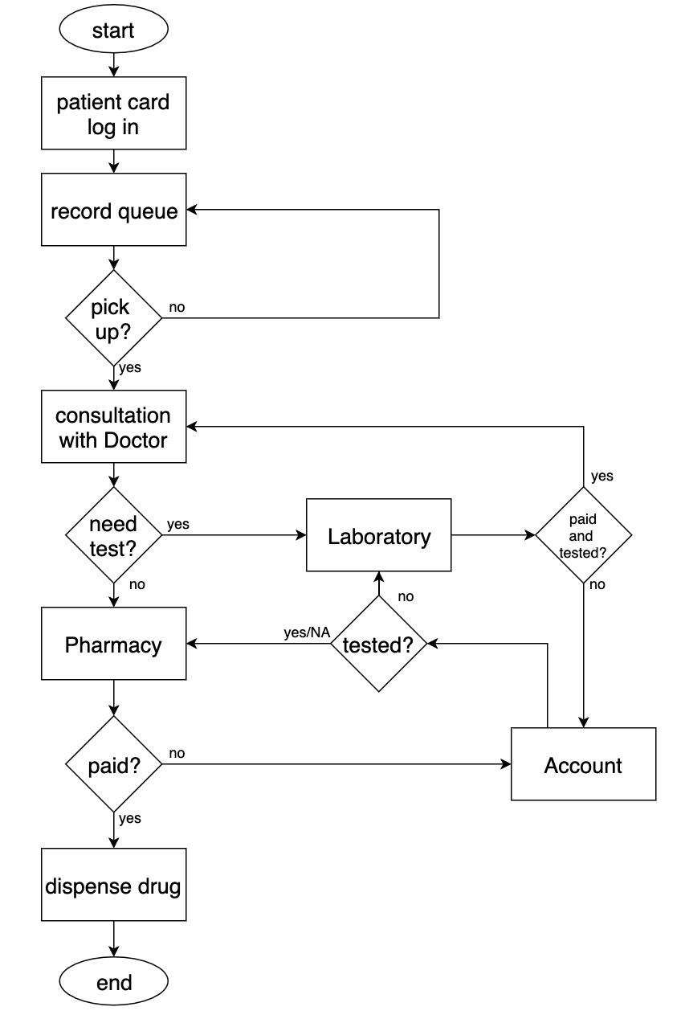

**Fig 11 : methodology overview**

A patient management system is a software platform tailored to streamline patient care processes within healthcare facilities, focusing on facilitating patient consultations and prescription management. Through this system, patients can efficiently schedule appointments with healthcare providers, consult with them regarding medical concerns, and receive prescribed medications. Healthcare professionals utilize the system to maintain detailed electronic health records (EHRs) for each patient, documenting medical history, diagnoses, and treatments. Additionally, the system enables providers to generate electronic prescriptions seamlessly, ensuring accurate medication orders and facilitating timely fulfillment at pharmacies. By prioritizing efficient consultations and prescription management, patient management systems aim to enhance the quality of patient care and optimize clinical workflows within healthcare settings.

**4. EXPERIMENTS AND RESULTS**

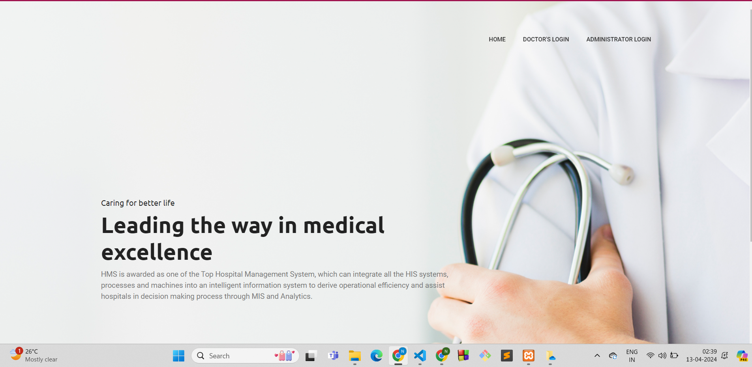

**Fig 12 :Home page**

This is the home page for our project/

**7.1. Screenshots of User Interface (UI) for the respective module**



Fig 13:Admin login page

This is the login page where admin can login into our system.



Fig 14:Admin Home page

Effortlessly streamline your patient management tasks with our Patient Management System's Admin Home Page. Seamlessly add new patient records, monitor healthcare provider activities, and ensure data security. Receive real-time updates on patient consultations and prescription activities, promoting transparency and accountability. Stay informed about appointment schedules and medication orders with timely notifications, ensuring efficient patient care delivery and inventory management.



Fig 15:ADMIN/register-patient

The Admin/Register Patient page within the patient management system offers medical officers real-time updates on newly added patient records from the backend database, ensuring access to the latest patient information. This page provides a user-friendly interface designed for efficient patient registration, allowing medical officers to input patient details effortlessly. The "View Details" option enables medical officers to thoroughly examine patient records, ensuring accurate and comprehensive documentation of patient information.



Fig 16:QR CODE SCANNER

Efficiently manage patient records with our QR code scanner, seamlessly integrating into your patient management system. Instantly retrieve and update vital information, enhancing accuracy and streamlining workflows for healthcare professionals.



Fig 17: Patient Management System - Medical Records Page

Within the Patient Management System, the Medical Records page is a critical component of healthcare provider workflows. It is divided into three sections: "Patient Information," "Medical History," and "Treatment Plans." The "Patient Information" section provides a comprehensive overview of patient demographics, contact details, and insurance information. In the "Medical History" section, healthcare providers can access detailed records of past diagnoses, treatments, and procedures. The "Treatment Plans" section allows for the creation and management of personalized treatment plans for each patient, including prescribed medications and follow-up appointments. This page streamlines patient care delivery by centralizing essential patient information and facilitating informed decision-making by healthcare providers.



Fig 18: Patient Management System - Laboratory Test Results Page

In the Patient Management System, the Laboratory Test Results page is a crucial tool for healthcare providers to access and manage patient diagnostic information. This page displays a comprehensive list of laboratory test results, including details such as test name, date conducted, and results interpretation. Healthcare providers can efficiently review and analyze test results to inform diagnosis and treatment decisions, facilitating timely and personalized patient care. Additionally, the page supports seamless communication between healthcare teams by allowing for easy sharing of test results with relevant stakeholders.

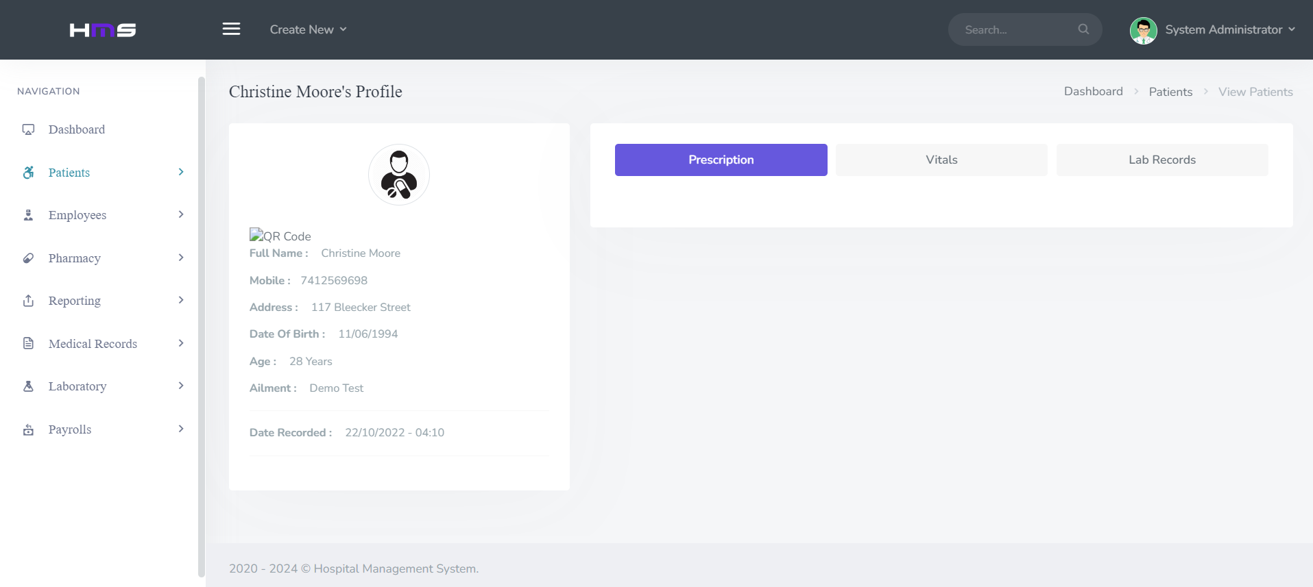

Fig 19-Patient Profile

The Patient Profile Page in the Patient Management System provides a concise overview of each patient's demographic details, medical history, and treatment plans. It facilitates efficient patient identification, enables informed decision-making by healthcare providers, and ensures continuity of care through detailed documentation of prescribed medications and scheduled appointments.

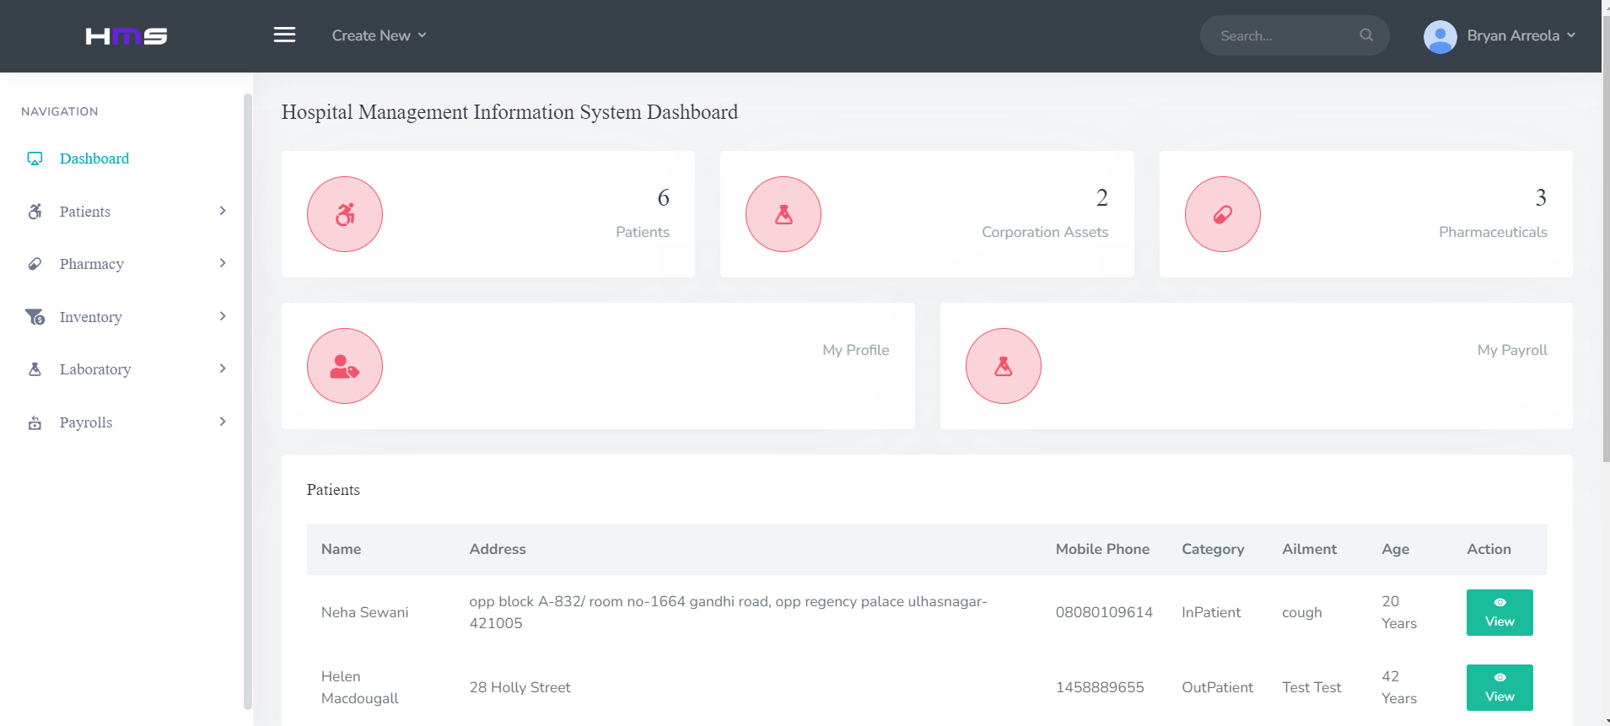

Fig 20:Doctor Panel/Dashboard

The Doctor Panel or Dashboard in the Patient Management System offers a centralized platform for healthcare professionals to access patient records, review medical histories, and manage treatment plans efficiently. It provides a user-friendly interface with quick navigation, allowing doctors to view appointment schedules, prescribe medications, and record clinical notes seamlessly. Additionally, the dashboard may include features such as real-time updates on patient statuses, alerts for critical conditions, and communication tools for collaboration among healthcare teams, enhancing overall patient care delivery.

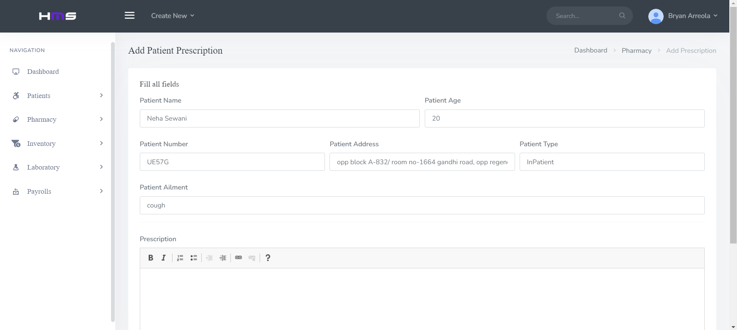

Fig 21:Doctor/Add Prescription Page

The Doctor's Add Prescription Page within the Patient Management System streamlines the process of prescribing medications for patients. It offers a user-friendly interface where doctors can input detailed prescription information, including medication name, dosage, frequency, and duration. The page may include features such as medication lookup, allergy alerts, and dosage recommendations to ensure accuracy and patient safety. Additionally, doctors can review patients' medical histories and current conditions to tailor prescriptions effectively, fostering personalized and optimal healthcare delivery.

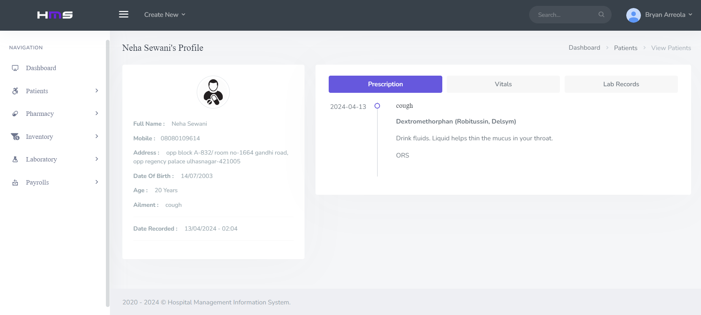

Fig 22: Doctor Panel/Patient profile

The Doctor Panel's Patient Profile section provides a comprehensive view of individual patient information, including medical history, treatment plans, and recent diagnostic results. It allows doctors to review patient demographics, past consultations, and prescribed medications efficiently. Additionally, it facilitates informed decision-making by offering quick access to relevant clinical data, enabling doctors to provide personalized care and monitor patient progress effectively.

**5. CONCLUSION**

1. ***Conclusion :***

In conclusion, patient management systems are integral components of modern healthcare infrastructure, offering a wide range of functionalities to streamline processes, enhance patient care, and improve overall healthcare outcomes. From maintaining comprehensive electronic health records to facilitating appointment scheduling, billing management, clinical decision support, and patient engagement, these systems play a crucial role in optimizing healthcare delivery. By leveraging technology to centralize patient information, improve communication among healthcare providers, and empower patients to actively participate in their care, patient management systems contribute to more efficient, effective, and patient-centered healthcare services. Moreover, with ongoing advancements in technology and increased focus on interoperability and data analytics, patient management systems continue to evolve, driving innovation and further enhancing the quality and accessibility of healthcare worldwide.

1. ***Future Work***

Future work is on the medicine stock system's database which include:

* Optimizing the database structure for efficiency.
* Ensuring real-time data updates and security.
* Developing data analytics, mobile access, and integration capabilities.
* Implementing predictive analysis, alerts, and notifications.
* Focusing on scalability and user training.

**6. REFERENCES**

1. [Baki Koyuncu; Hakan Koyuncu], "Intelligent Hospital Management System," in Proceedings of [2015 International Conference on Computational Intelligence and Communication Networks (CICN)], [2015]. DOI: [10.1109/CICN.2015.305].
2. [Srijani Mukherjee; Koustabh Dolui; Soumya Kanti Datta], "Patient Health Management System using e-health monitoring architecture," in Proceedings of [2014 IEEE International Advance Computing Conference (IACC)], [2014]. DOI: [10.1109/IAdCC.2014.6779357].
3. [D. Shiva Rama Krishnan; Subhash Chand Gupta; Tanupriya Choudhury], "An IoT based Patient Health Monitoring System," in Proceedings of [2018 International Conference on Advances in Computing and Communication Engineering (ICACCE)], [2018]. DOI: [10.1109/ICACCE.2018.8441708].
4. [Belal Chowdhury; Rajiv Khosla], "RFID-based Hospital Real-time Patient Management System," in Proceedings of [6th IEEE/ACIS International Conference on Computer and Information Science (ICIS 2007)], [2007]. DOI: [10.1109/ICIS.2007.159].
5. [Iuliana Chiuchisan; Hariton-Nicolae Costin; Oana Geman], "Adopting the Internet of Things technologies in health care systems," in Proceedings of [2014 International Conference and Exposition on Electrical and Power Engineering (EPE)], [2014]. DOI: [10.1109/ICEPE.2014.6969965].

**Plagiarism report**

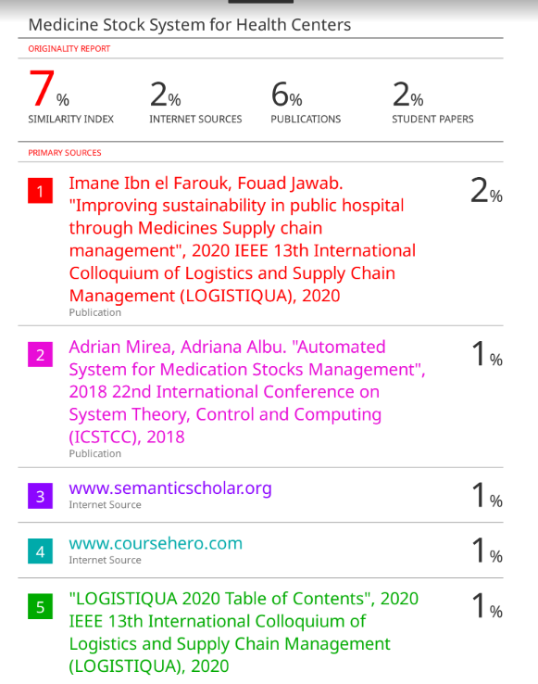



**Project review sheet**

Review 1:

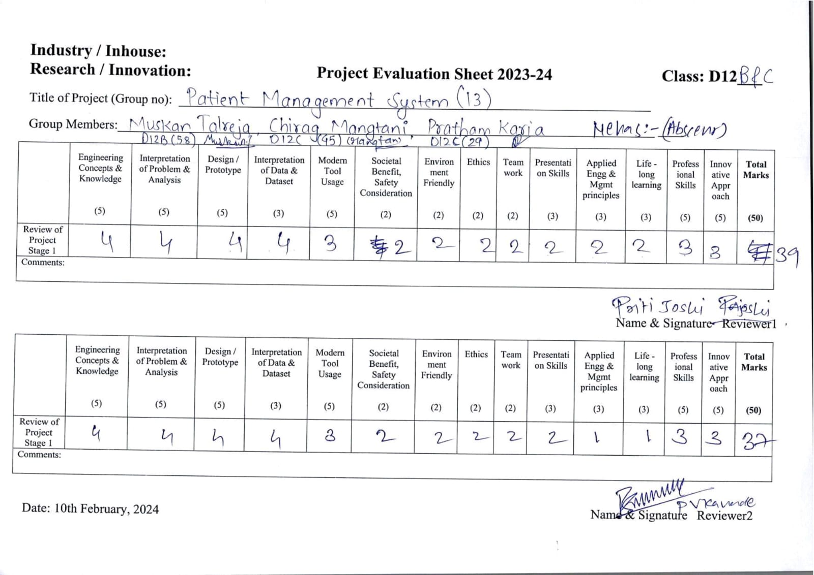

Review 2:

